**Waste Management**

**Dataset:**

The dataset is waste sensor data.

**Implementation:**

1. **Import Libraries**

Code:

import pandas as pd

import numpy as np

1. **Load dataset**

Code:

data=pd.read_csv('/content/waste_sensor_data.csv')

data

Output:

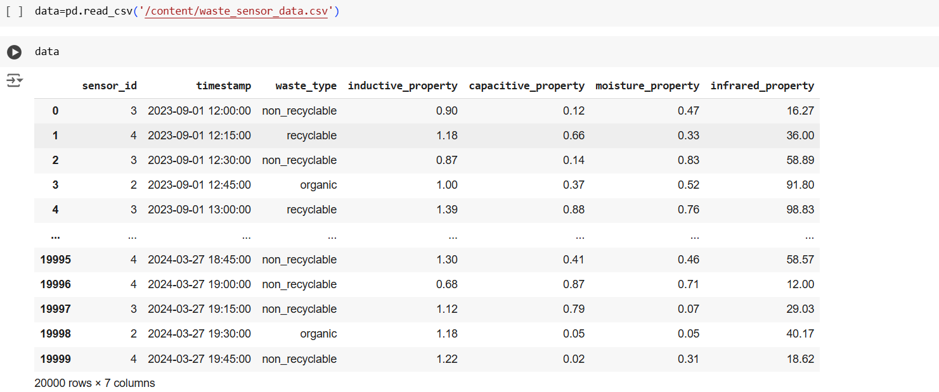

1. **About dataset**

Code:

data.head()

Output:

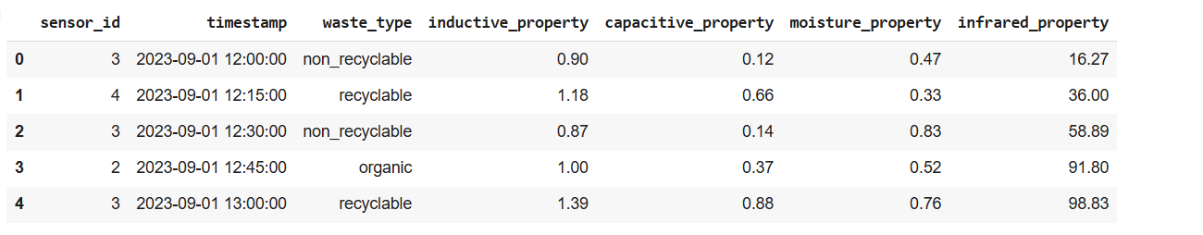

Code:

data.tail()

Output:

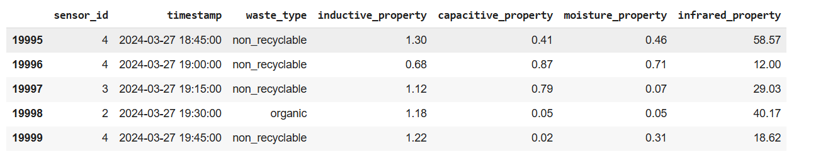

Code:

data.describe()

Output:

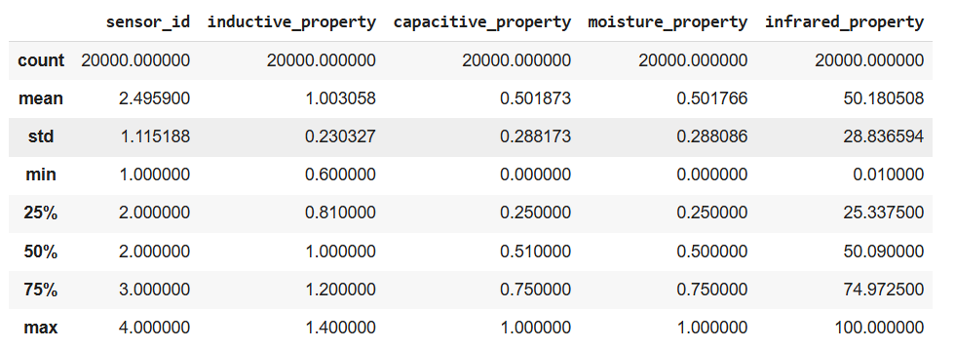

Code:

data.info()

Output:

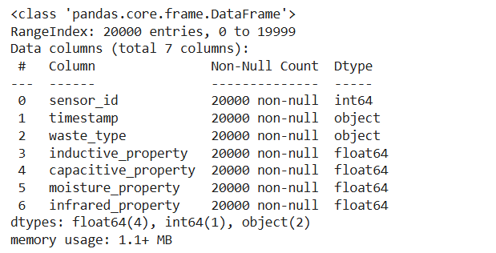

Code:

data.dtypes

Output:

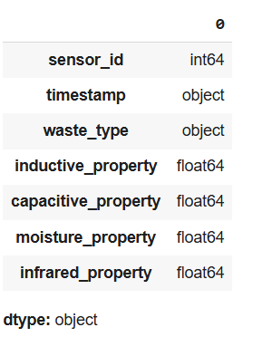

Code:

data.isnull()

Output:

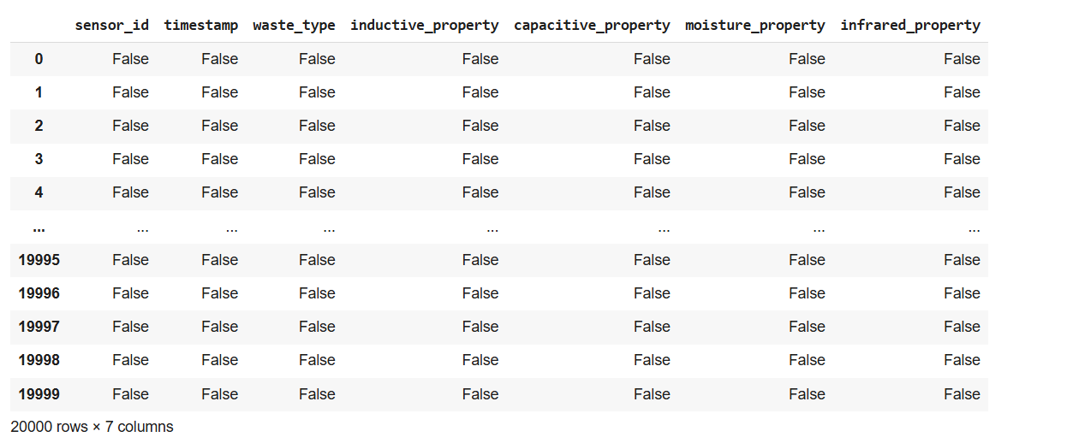

Code:

data.isnull().sum()

Output:

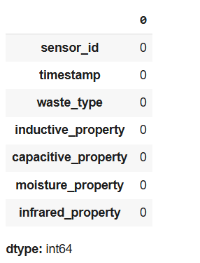

Code:

data.duplicated().sum()

Output:

0

Code:

data['waste_type'].unique()

Output:

array(['non_recyclable', 'recyclable', 'organic'], dtype=object)

Code:

data['waste_type'].value_counts()

Output:

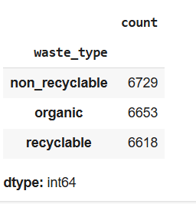

Code:

numeric_data = data.select_dtypes(include=np.number)

numeric_data['waste_type'] = data['waste_type']

grouped_data = numeric_data.groupby('waste_type').mean()

print(grouped_data)

Output:

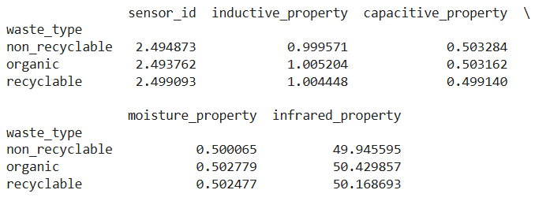

Code:

data.nunique()

Output:

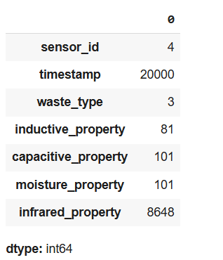

Code:

data.groupby('waste_type').agg(['mean', 'median', 'std', 'min', 'max'])

Output:

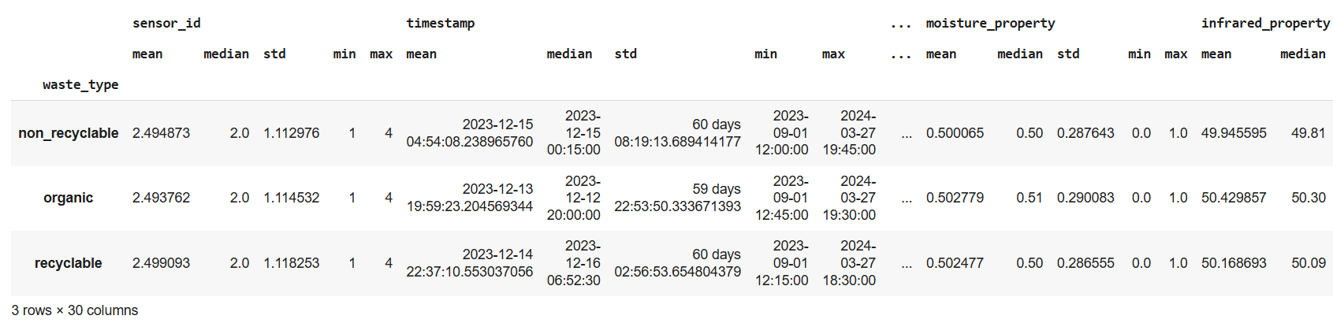 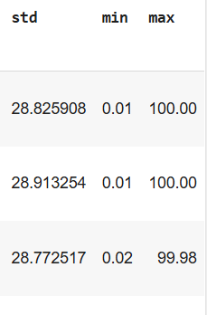

Code:

data.var(numeric_only=True)

Output:

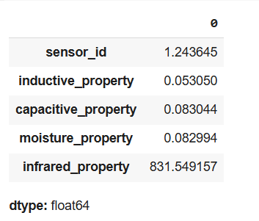

Code:

data['waste_type'].value_counts(normalize=True) * 100

Output:

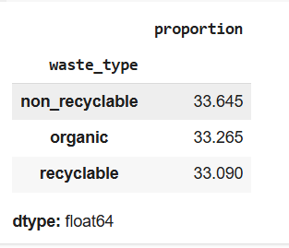

Code:

from statsmodels.stats.outliers_influence import variance_inflation_factor

X = data.select_dtypes(include='number')

vif = pd.DataFrame()

vif['Feature'] = X.columns

vif['VIF'] = [variance_inflation_factor(X.values, i) for i in range(X.shape[1])]

print(vif)

Output:

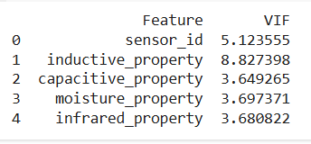

Code:

data.groupby('waste_type').agg(

    max_moisture=('moisture_property', 'max'),

    avg_moisture=('moisture_property', 'mean'),

    total_entries=('moisture_property', 'count')

)

Output:

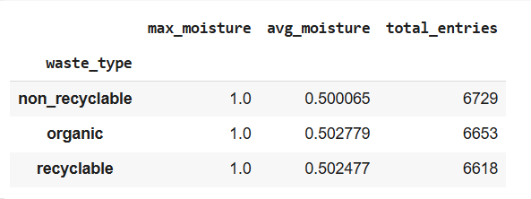

1. **Graphs and maps- Data visualization**

Code:

import matplotlib.pyplot as plt

data['waste_type'].value_counts().plot(kind='bar', color='skyblue')

plt.title('Distribution of Waste Types')

plt.xlabel('Waste Type')

plt.ylabel('Count')

plt.show()

Output:

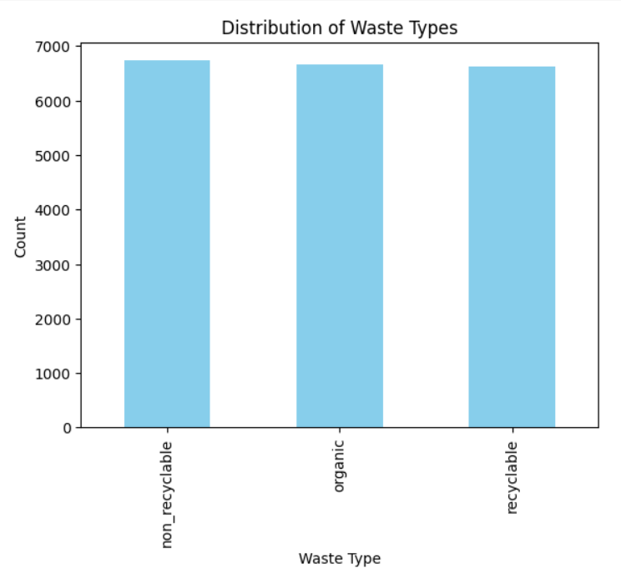

Code:

import seaborn as sns

import matplotlib.pyplot as plt

numeric_data = data.select_dtypes(include=np.number)

plt.figure(figsize=(10, 6))

sns.heatmap(numeric_data.corr(), annot=True, cmap='coolwarm', fmt=".2f")

plt.title('Correlation Matrix')

plt.show()

Output:

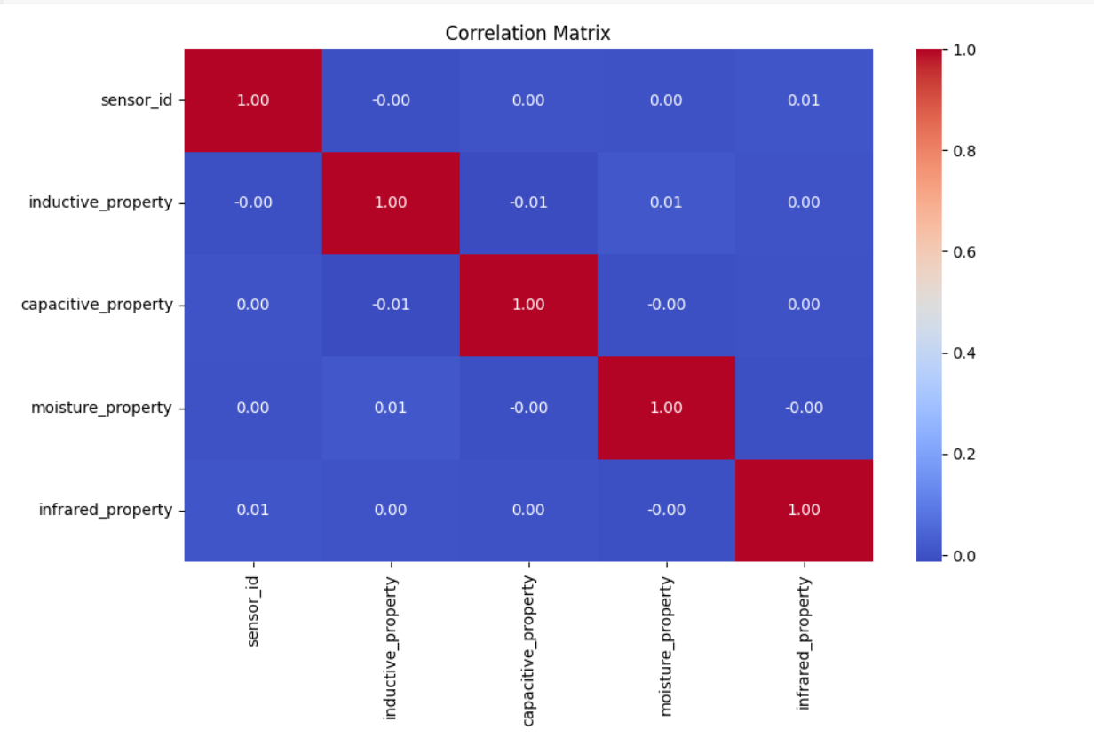

Code:

sns.scatterplot(data=data, x='inductive_property', y='moisture_property', hue='waste_type')

plt.title('Inductive vs Moisture Property')

plt.show()

Output:

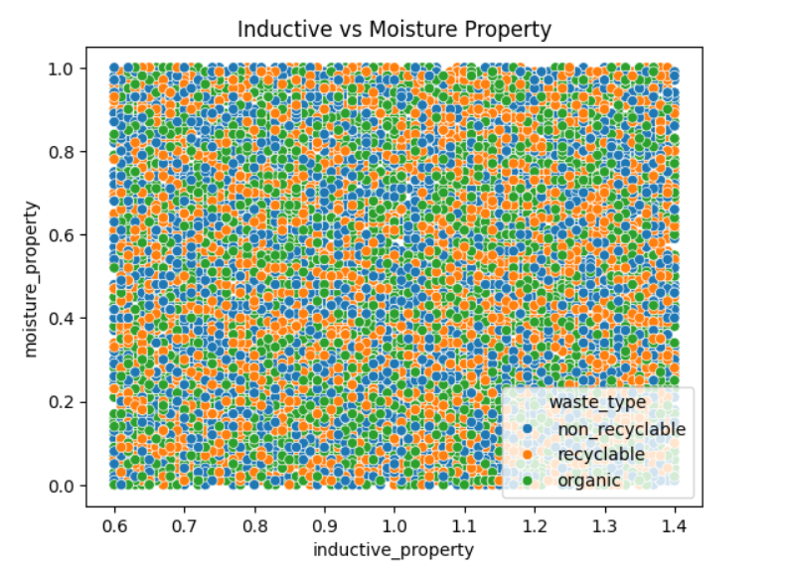

Code:

data['timestamp'] = pd.to_datetime(data['timestamp'])

data.set_index('timestamp').groupby('waste_type')['sensor_id'].resample('D').count().unstack(0).plot(figsize=(10, 6))

plt.title('Waste Type Counts Over Time')

plt.ylabel('Count')

plt.show()

Output:

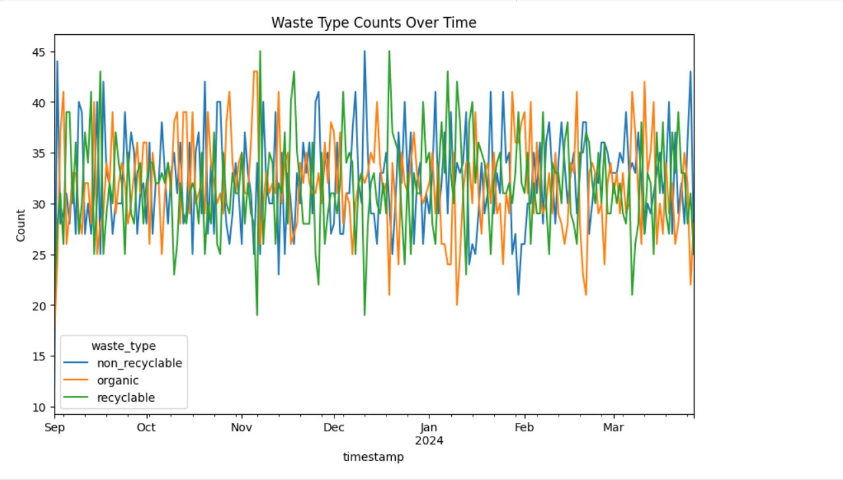

Code:

sns.pairplot(data, hue='waste_type', diag_kind='kde', palette='Set2')

plt.suptitle("Pairwise Relationships Between Variables", y=1.02)

plt.show()

Output:

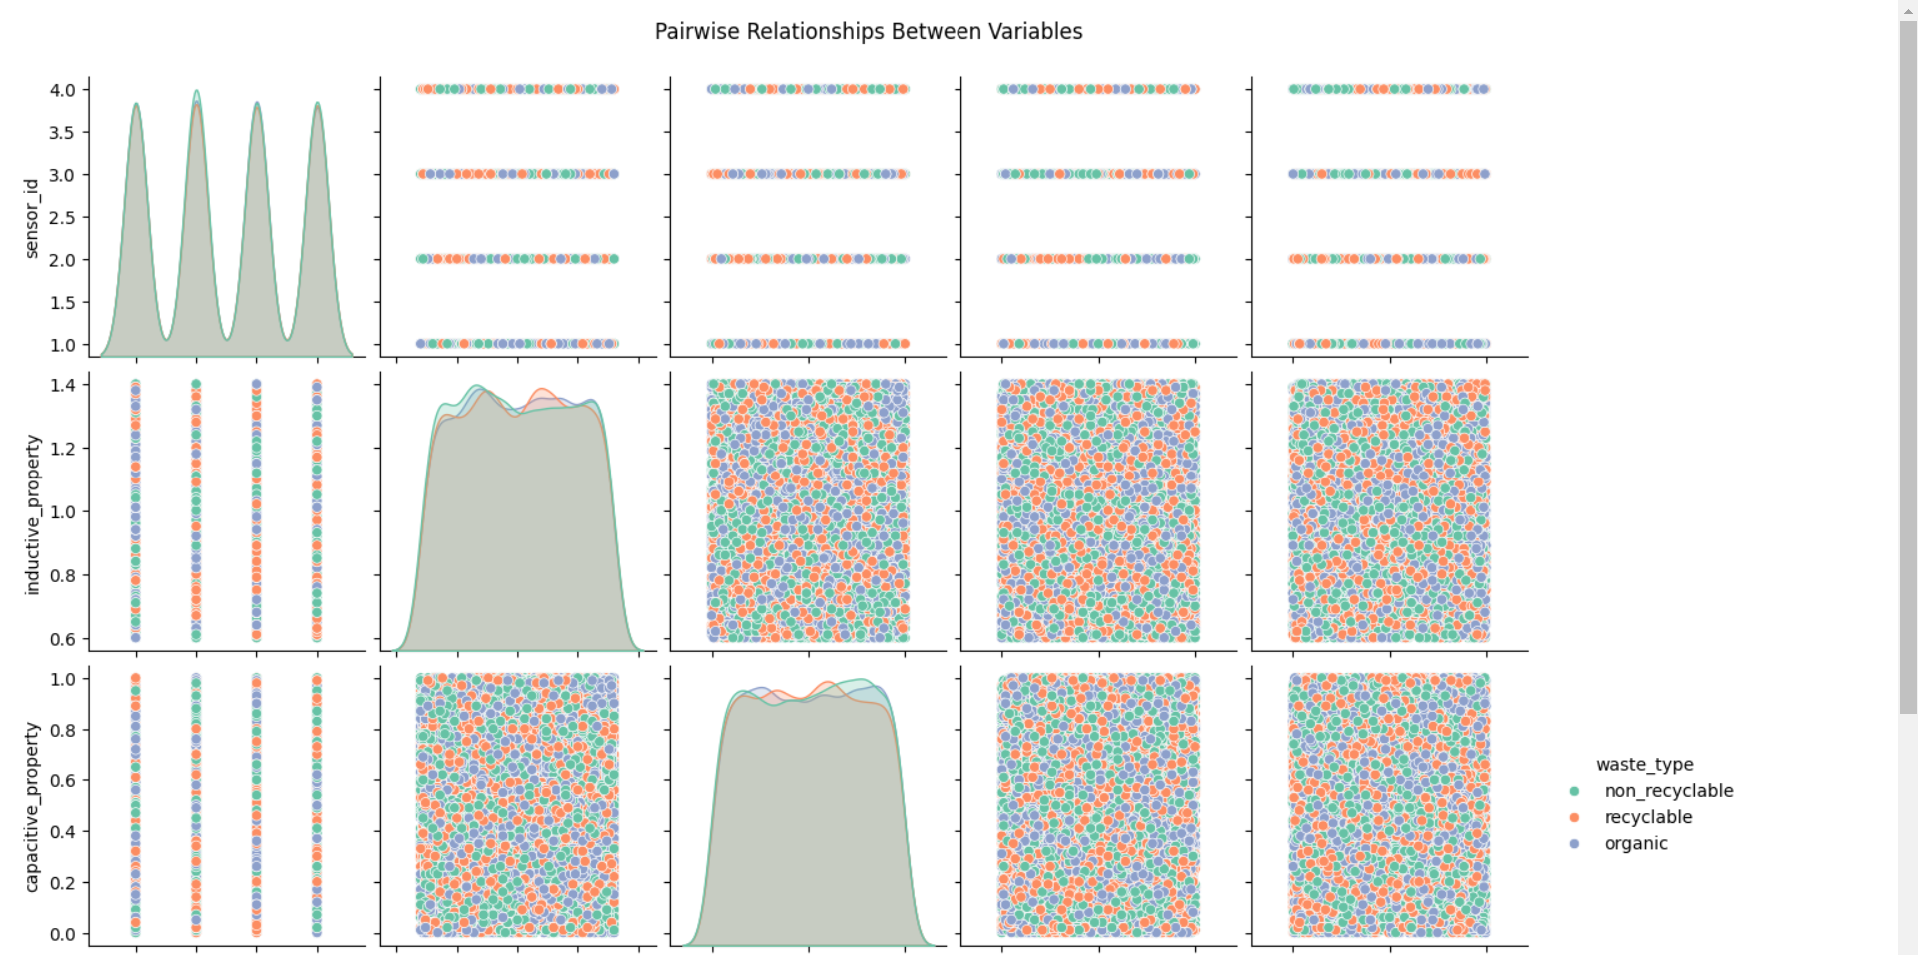 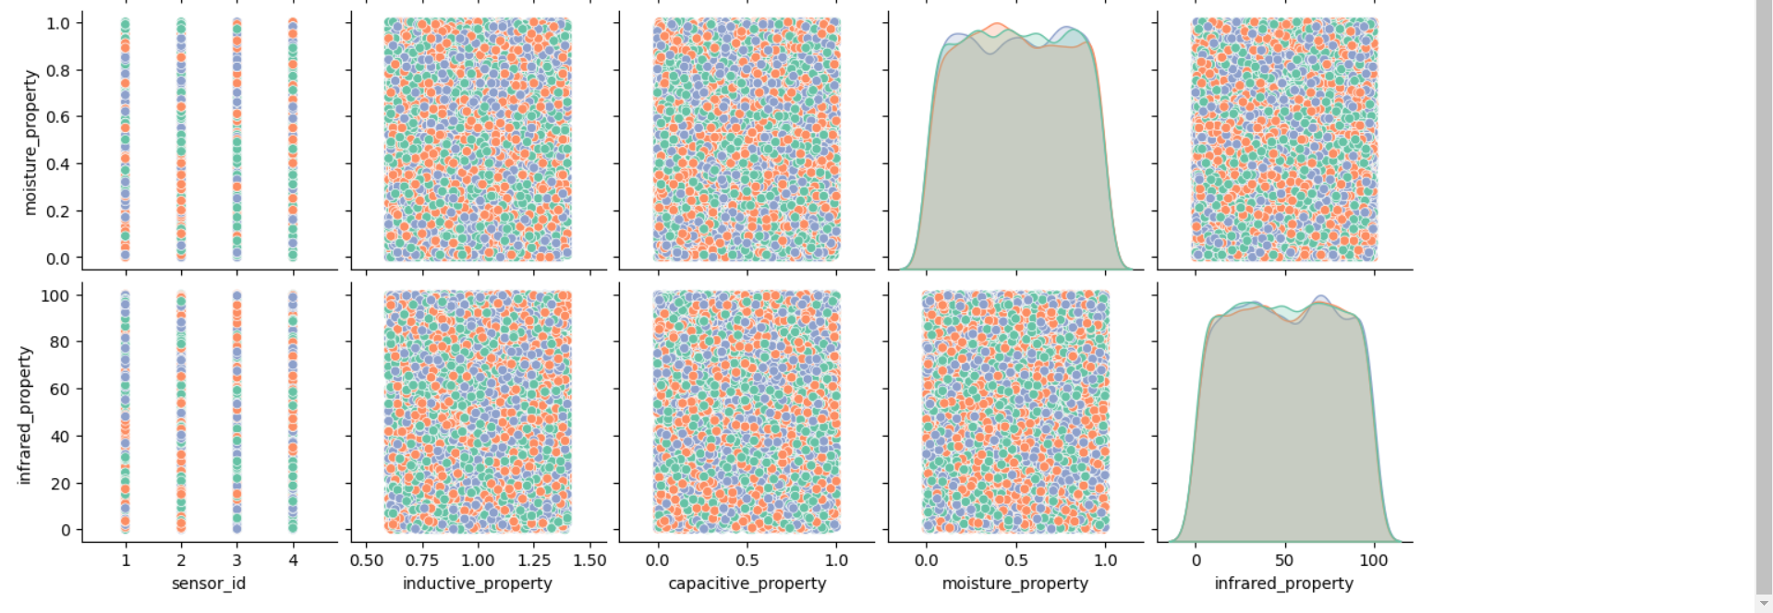

Code:

sns.boxplot(data=data, x='waste_type', y='moisture_property', palette='pastel')

plt.title('Moisture Property Across Waste Types')

plt.show()

Output:

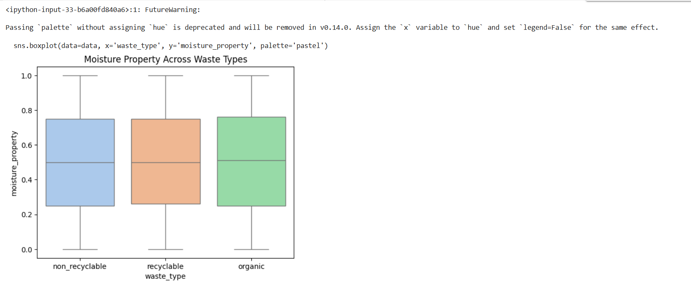

Code:

sns.violinplot(data=data, x='waste_type', y='infrared_property', palette='muted')

plt.title('Infrared Property Distribution Across Waste Types')

plt.show()

Output:

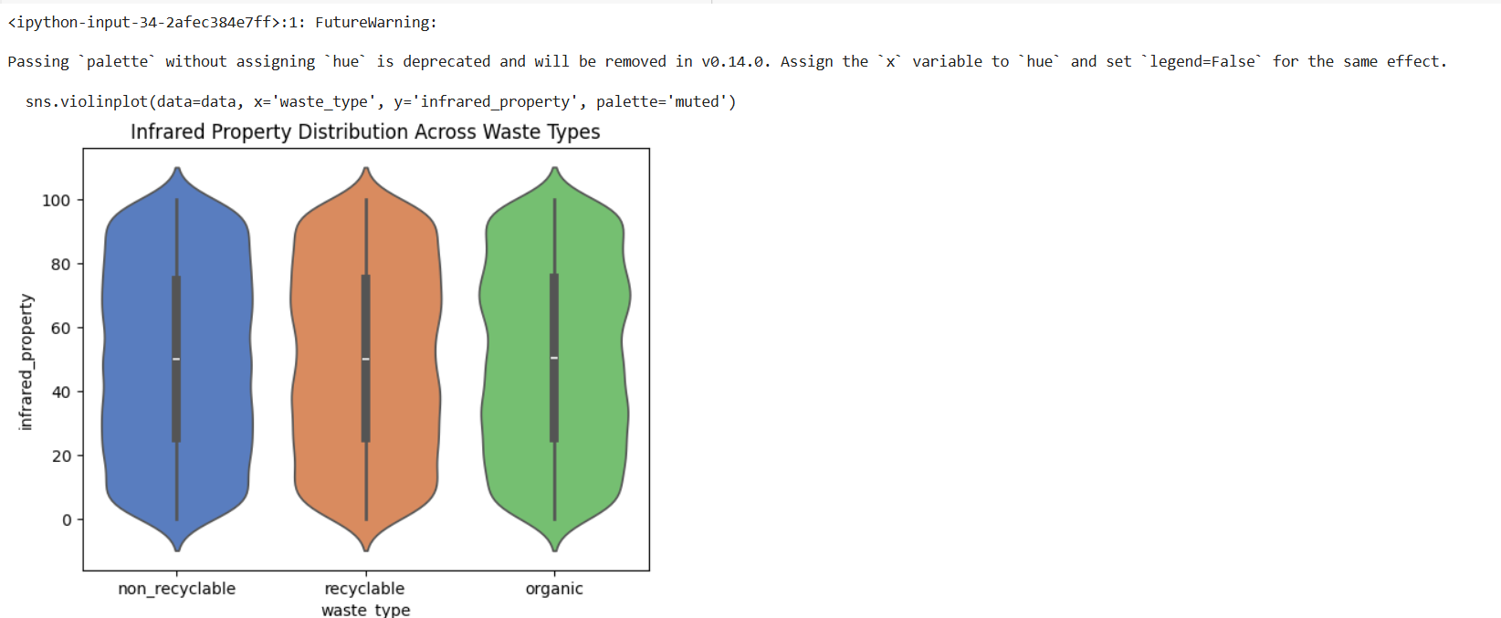

Code:

numeric_data = data.select_dtypes(include=np.number)

correlation_matrix = numeric_data.corr()

plt.figure(figsize=(10, 6))

sns.heatmap(correlation_matrix, annot=True, fmt='.2f', cmap='coolwarm', linewidths=0.5)

plt.title('Correlation Heatmap')

plt.show()

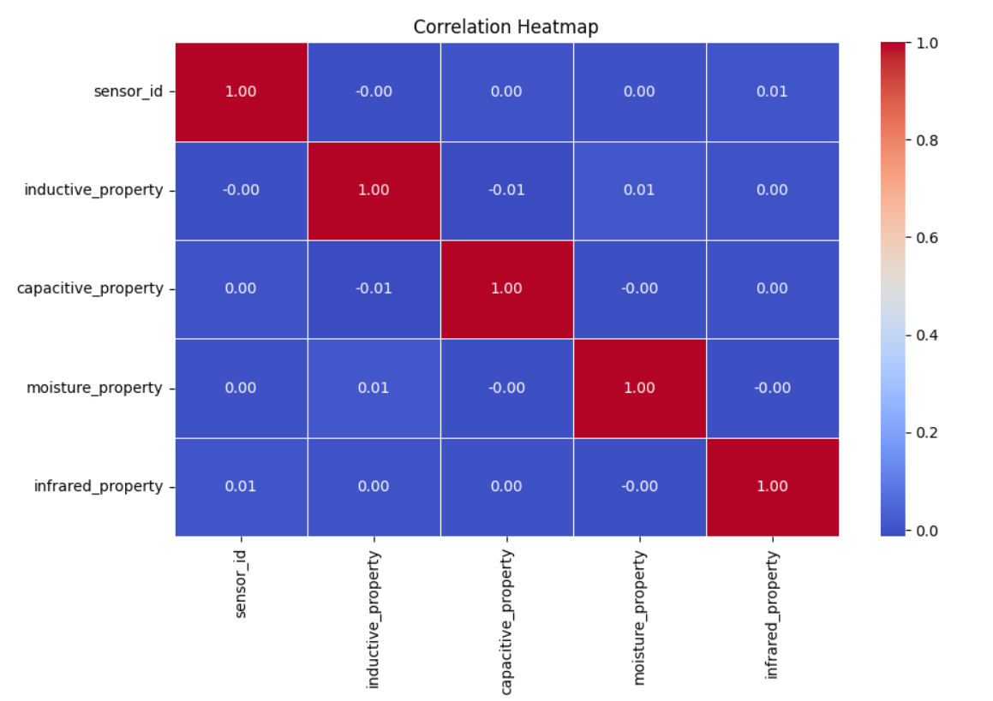

Code:

sns.scatterplot(data=data, x='capacitive_property', y='moisture_property', hue='waste_type', palette='Set1')

plt.title('Capacitive vs Moisture Property')

plt.show()

Output:

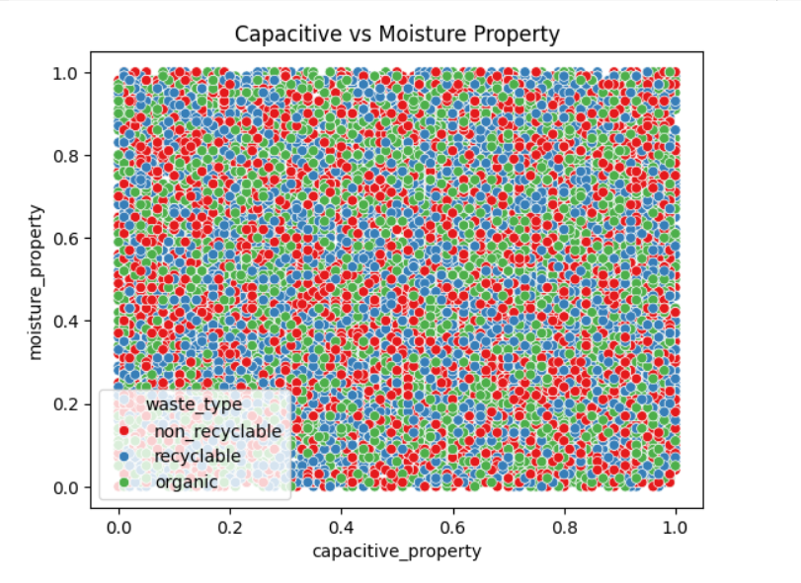

Code:

sns.histplot(data['inductive_property'], kde=True, color='purple')

plt.title('Distribution of Inductive Property')

plt.show()

Output:

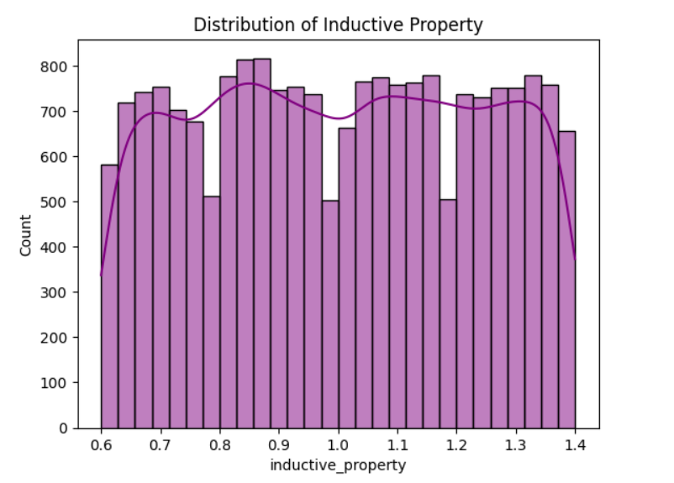

Code:

plt.figure(figsize=(12, 6))

sns.lineplot(data=data, x='timestamp', y='infrared_property', hue='waste_type', palette='viridis')

plt.title('Infrared Property Over Time')

plt.xticks(rotation=45)

plt.show()

Output:

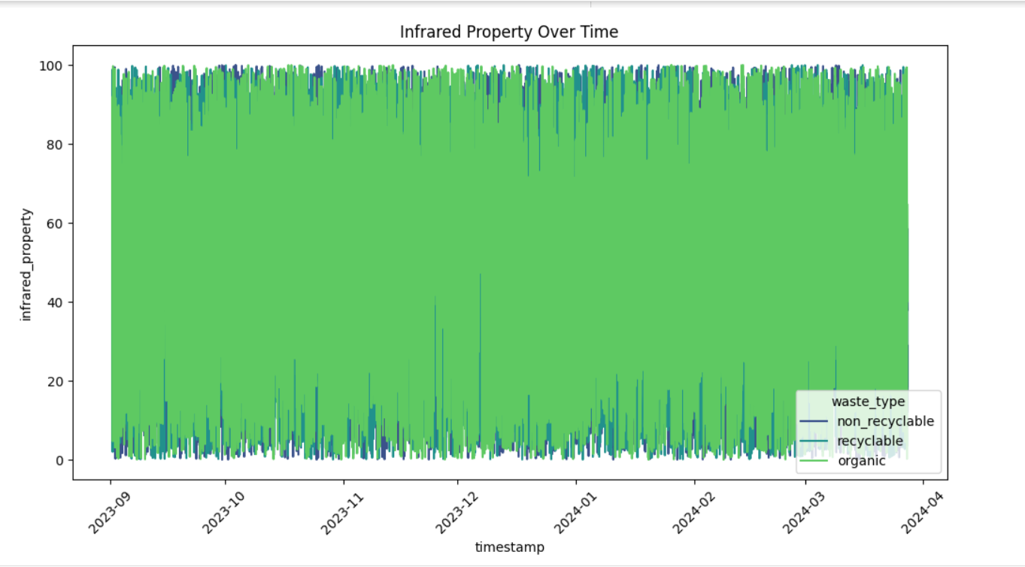

Code:

sns.boxplot(data=data, y='capacitive_property', color='lightblue')

plt.title('Outliers in Capacitive Property')

plt.show()

Output:

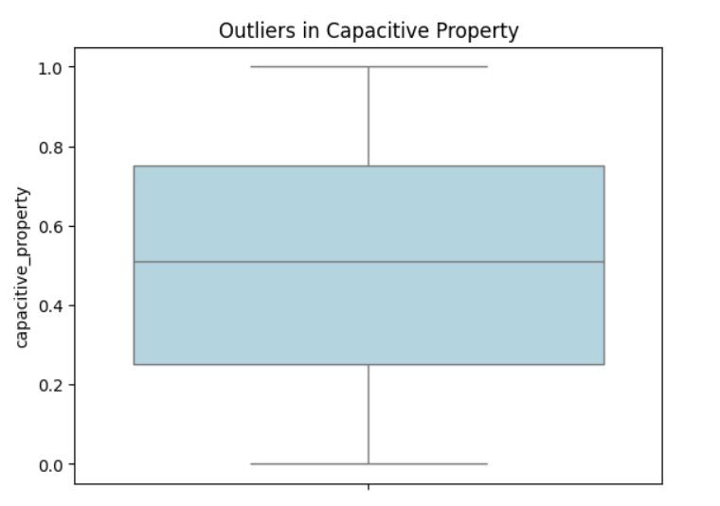

Code:

sns.countplot(data=data, x='waste_type', palette='Set3')

plt.title('Frequency of Waste Types')

plt.show()

Output:

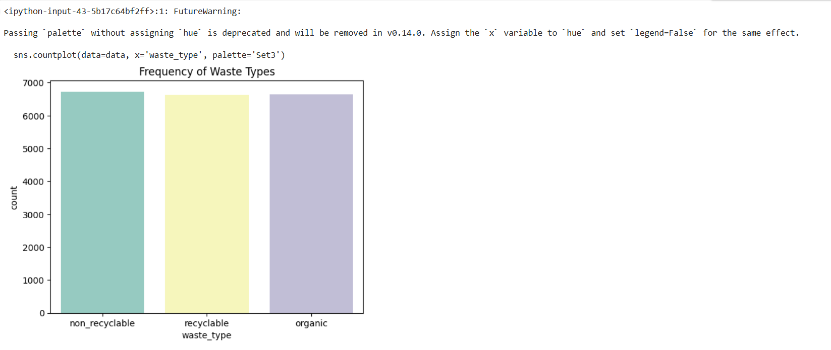

Code:

sns.ecdfplot(data['moisture_property'], color='green')

plt.title('Cumulative Distribution of Moisture Property')

plt.show()

Output:

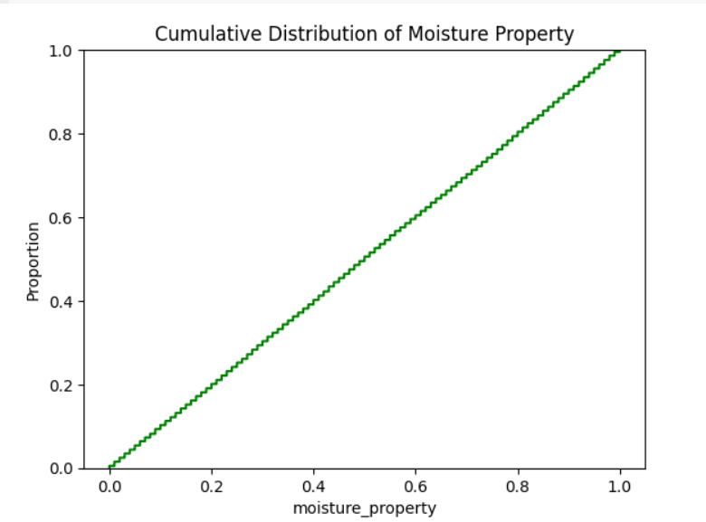

Code:

time_trend = data.groupby([data['timestamp'].dt.date, 'waste_type']).size().unstack(fill_value=0)

time_trend.plot(kind='line', figsize=(12, 6))

plt.title('Time-Based Trends of Waste Types')

plt.xlabel('Date')

plt.ylabel('Count')

plt.show()

Output:

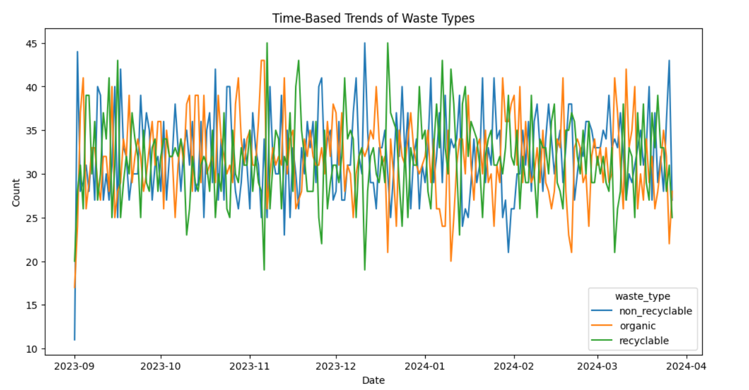

Code:

data.groupby('waste_type')['inductive_property'].mean().plot(kind='bar', color='orange')

plt.title('Average Inductive Property for Each Waste Type')

plt.xlabel('Waste Type')

plt.ylabel('Average Inductive Property')

plt.show()

Output:

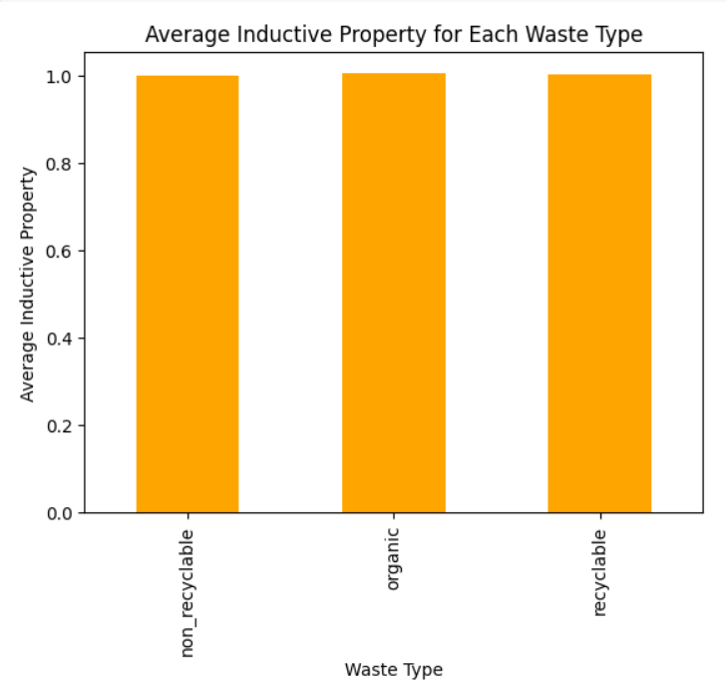

1. **Data Preprocessing**

Code:

import pandas as pd

from sklearn.preprocessing import LabelEncoder, StandardScaler

from sklearn.model_selection import train_test_split

data.fillna(data.mean(), inplace=True)

data

Output:

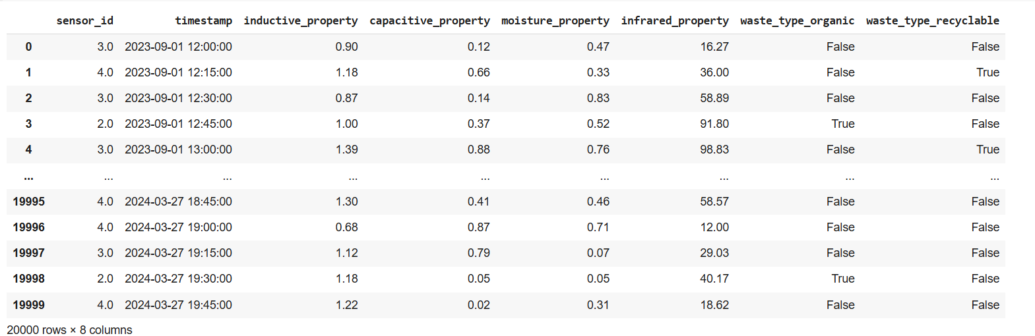

Code:

print(data['waste_type_organic'].value_counts())

Output:

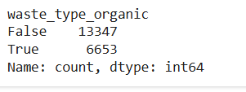

Code:

data['timestamp'] = pd.to_datetime(data['timestamp'])

data['hour'] = data['timestamp'].dt.hour

data['day_of_week'] = data['timestamp'].dt.dayofweek

data.drop(columns=['timestamp'], inplace=True)

label_encoder = LabelEncoder()

data['waste_type_organic'] = label_encoder.fit_transform(data['waste_type_organic'])

print(dict(zip(label_encoder.classes_, label_encoder.transform(label_encoder.classes_))))

Output:

{False: 0, True: 1}

Code:

scaler = StandardScaler()

numerical_columns = ['inductive_property', 'capacitive_property', 'moisture_property', 'infrared_property', 'hour', 'day_of_week']

data[numerical_columns] = scaler.fit_transform(data[numerical_columns])

X = data.drop(columns=['waste_type_organic'])

y = data['waste_type_organic']

X_train, X_test, y_train, y_test = train_test_split(X, y, test_size=0.2, random_state=42, stratify=y)

data

Output:

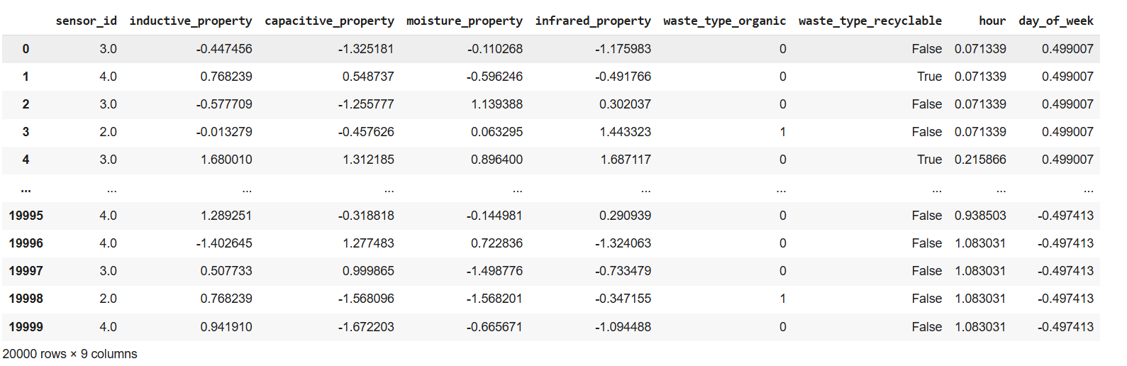Code:

print(f"Number of duplicate rows: {data.duplicated().sum()}")

data = data.drop_duplicates()

print(f"Number of duplicate rows after removal: {data.duplicated().sum()}")

Output:

Number of duplicate rows: 0

Number of duplicate rows after removal: 0

Code:

data.fillna(data.mean(), inplace=True)

categorical_columns = data.select_dtypes(include=['object']).columns

for col in categorical_columns:

    data[col].fillna(data[col].mode()[0], inplace=True)

print(data.isnull().sum())

Output:

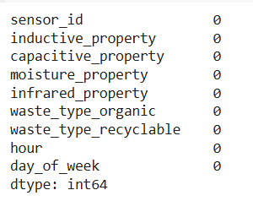

Code:

for col in numerical_columns:

    Q1 = data[col].quantile(0.25)

    Q3 = data[col].quantile(0.75)

    IQR = Q3 - Q1

    lower_bound = Q1 - 1.5 * IQR

    upper_bound = Q3 + 1.5 * IQR

    data[col] = data[col].clip(lower=lower_bound, upper=upper_bound)

print(data[numerical_columns].describe())

Output:

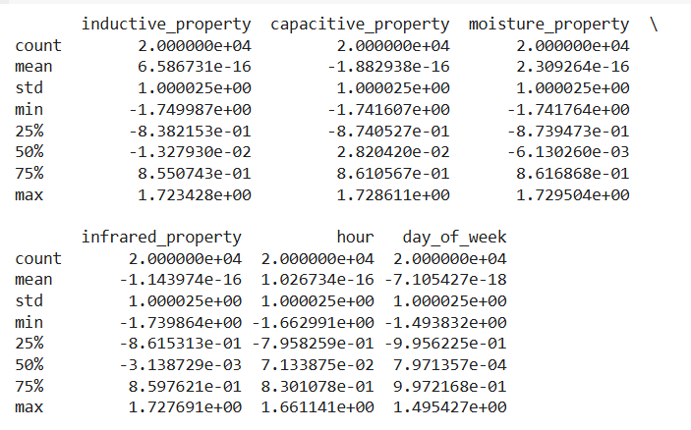

Code:

print(data['waste_type_organic'].value_counts())

from imblearn.over_sampling import SMOTE

smote = SMOTE(random_state=42)

X, y = smote.fit_resample(X, y)

print(pd.Series(y).value_counts())

Output:

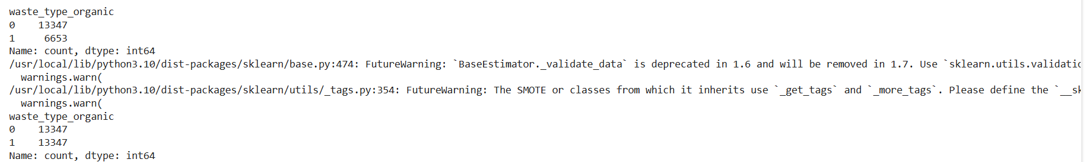

Code:

data['inductive_capacitive'] = data['inductive_property'] * data['capacitive_property']

data['moisture_infrared'] = data['moisture_property'] * data['infrared_property']

print(data.head())

Output:

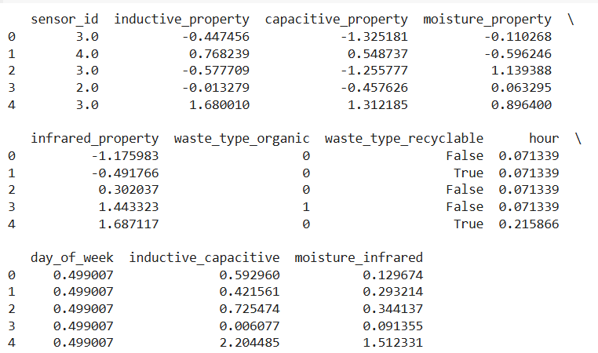

Code:

correlation_matrix = data.corr()

high_corr_features = [col for col in correlation_matrix.columns if any(abs(correlation_matrix[col]) > 0.9) and col != 'waste_type']

data.drop(columns=high_corr_features, inplace=True)

print(f"Dropped features: {high_corr_features}")

Output:



Code:

from sklearn.preprocessing import PolynomialFeatures

poly = PolynomialFeatures(degree=2, include_bias=False)

X_poly = poly.fit_transform(X)

print(f"Shape of feature matrix before: {X.shape}, after: {X_poly.shape}")

Output:

Shape of feature matrix before: (26694, 8), after: (26694, 44)

Code:

from sklearn.decomposition import PCA

pca = PCA(n_components=0.95)

X_reduced = pca.fit_transform(X)

print(f"Shape before PCA: {X.shape}, after PCA: {X_reduced.shape}")

Output:



Code:

from sklearn.preprocessing import MinMaxScaler

scaler = MinMaxScaler()

X_scaled = scaler.fit_transform(X)

print(pd.DataFrame(X_scaled).describe())

Output:

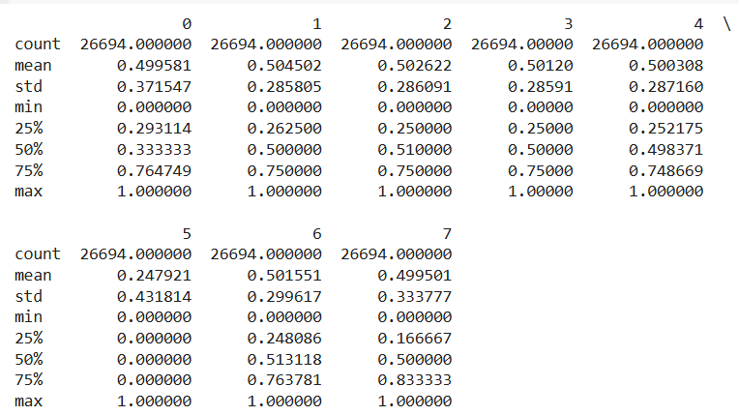

1. **Model**

Code:

from sklearn.model_selection import train_test_split

X_train, X_test, y_train, y_test = train_test_split(X_scaled, y, test_size=0.2, random_state=42, stratify=y)

print(f"Training size: {X_train.shape}, Testing size: {X_test.shape}")

Output:



Code:

from sklearn.ensemble import RandomForestClassifier

from sklearn.metrics import accuracy_score, classification_report, confusion_matrix

rf_classifier = RandomForestClassifier(

    n_estimators=100,

    max_depth=None,

    random_state=42,

    class_weight='balanced'

)

rf_classifier.fit(X_train, y_train)

Output:



Code:

y_pred = rf_classifier.predict(X_test)

accuracy = accuracy_score(y_test, y_pred)

print(f"Accuracy: {accuracy * 100:.2f}%")

print("\nClassification Report:")

print(classification_report(y_test, y_pred))

print("\nConfusion Matrix:")

print(confusion_matrix(y_test, y_pred))

Output:

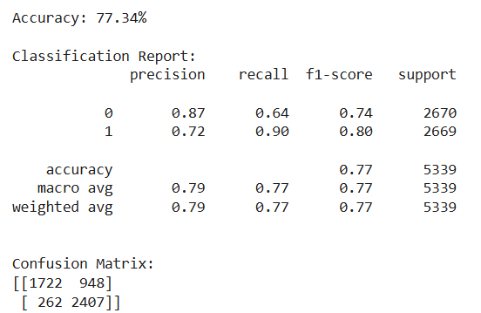

Code:

importances = rf_classifier.feature_importances_

feature_importances = pd.DataFrame({

    'Feature': X.columns,

    'Importance': importances

}).sort_values(by='Importance', ascending=False)

print("\nFeature Importances:")

print(feature_importances)

Output:

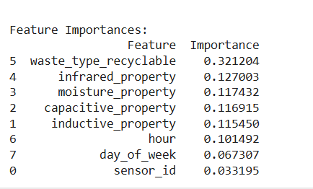

Code:

!pip install xgboost

import xgboost as xgb

from sklearn.metrics import accuracy_score, classification_report, confusion_matrix

xgb_classifier = xgb.XGBClassifier(

    objective='binary:logistic',

    random_state=42,

    eval_metric='logloss'

)

xgb_classifier.fit(X_train, y_train)

y_pred = xgb_classifier.predict(X_test)

accuracy = accuracy_score(y_test, y_pred)

print(f"Accuracy: {accuracy * 100:.2f}%")

print("\nClassification Report:")

print(classification_report(y_test, y_pred))

print("\nConfusion Matrix:")

print(confusion_matrix(y_test, y_pred))

Output:

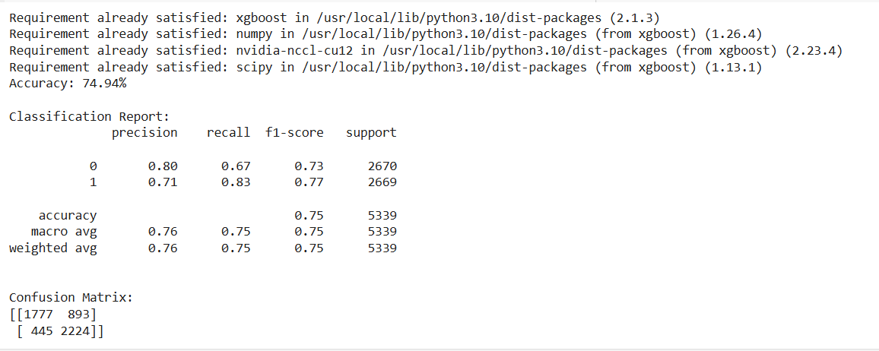Code:

import pandas as pd

import numpy as np

import matplotlib.pyplot as plt

from sklearn.model_selection import train_test_split

from sklearn.preprocessing import StandardScaler, LabelEncoder

from sklearn.metrics import accuracy_score

from sklearn.ensemble import RandomForestClassifier

import xgboost as xgb

from sklearn.linear_model import LogisticRegression

from sklearn.svm import SVC

from sklearn.neighbors import KNeighborsClassifier

from sklearn.tree import DecisionTreeClassifier

from sklearn.naive_bayes import GaussianNB

classifiers = {

    'Logistic Regression': LogisticRegression(max_iter=1000, random_state=42),

    'SVM': SVC(random_state=42),

    'K-Nearest Neighbors': KNeighborsClassifier(),

    'Decision Tree': DecisionTreeClassifier(random_state=42),

    'Naive Bayes': GaussianNB(),

    'Random Forest': RandomForestClassifier(random_state=42),

    'XGBoost': xgb.XGBClassifier(random_state=42, eval_metric='logloss')

}

accuracies = {}

for name, clf in classifiers.items():

    try:

        clf.fit(X_train, y_train)

        y_pred = clf.predict(X_test)

        accuracy = accuracy_score(y_test, y_pred)

        accuracies[name] = accuracy

        print(f"{name}: Accuracy = {accuracy}")

    except Exception as e:

        print(f"Error training {name}: {e}")

        accuracies[name] = 0

plt.figure(figsize=(12, 6))

plt.bar(accuracies.keys(), accuracies.values(), color='skyblue')

plt.xlabel("Classifier")

plt.ylabel("Accuracy")

plt.title("Classifier Accuracies")

plt.xticks(rotation=45, ha='right')

plt.tight_layout()

plt.show()

